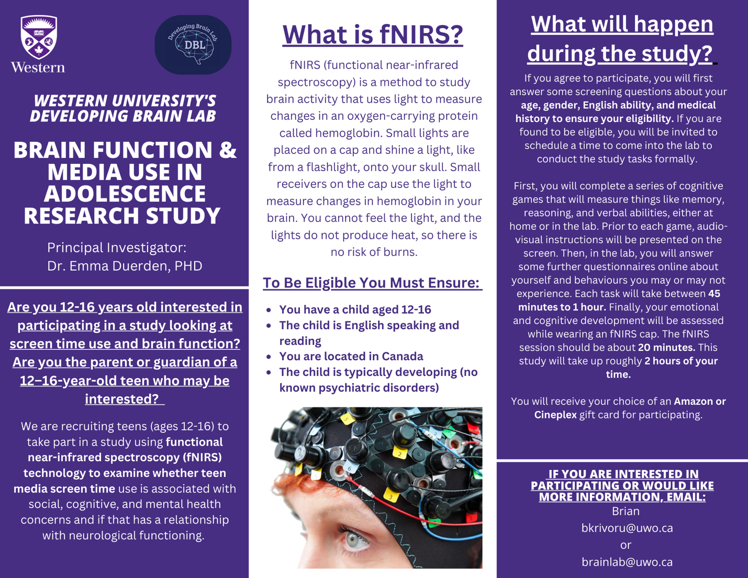

Teens 12-16 years of age are invited to participate in our fNIRs study assessing the association between screen time use, mental health, and neurological functioning. First, you will complete a series of cognitive games that will measure things like memory, reasoning, and verbal abilities, either at home or in the lab. Prior to each game, audio-visual instructions will be presented on the screen. Then, in the lab, you will answer some further questionnaires online about yourself and behaviours you may or may not experience. Each task will take between 45 minutes to 1 hour. Finally, your emotional and cognitive development will be assessed while wearing an fNIRS cap. The fNIRS session should be about 20 minutes. This study will take up roughly 2 hours of your time. You will be compensated for your participation. For more information, visit https://www.developingbrain.ca/ or email Brian at bkrivoru@uwo.ca

