Children aged 7-10 years and their parents needed for a study on social interactions!

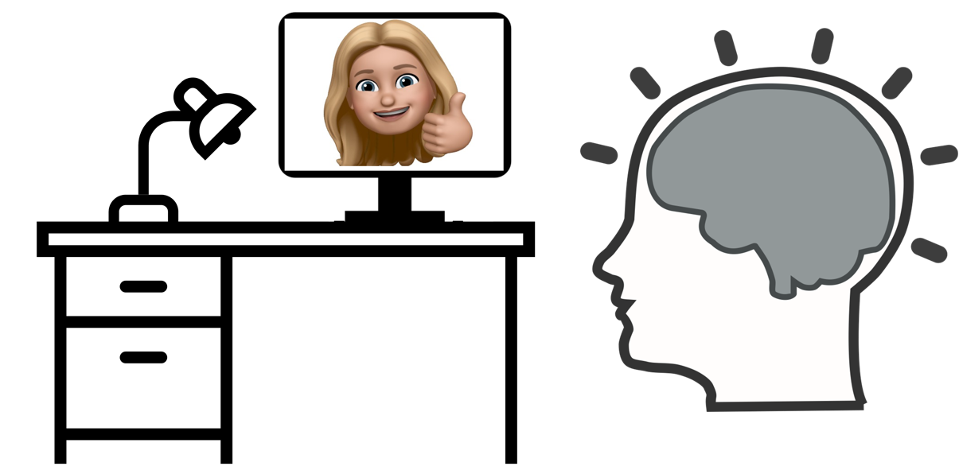

The Developing Brain lab is looking for children aged 7-10 years old to take part in a study which examines brain activity while watching videos or speaking to another person.
Parents: During your visit you will be asked to fill out some questionnaires while your child completes some paper and pencil tests. Following this, your child will complete visual tasks on a computer while we measure eye behaviours and brain activity.
Your participation would involve 1 session, and will be about 1.5 hours.
In appreciation for your time, your child will receive a gift card.
For more information about this study, or to volunteer for this study,
please contact:
Researcher: Michaela Kent, PhD Student in Neuroscience
Email: mkent28@uwo.ca
Principal Investigator: Dr. Emma Duerden, Faculty of Education
519-661-2111 Ext. 88694 or
Email: brainlab@uwo.ca

